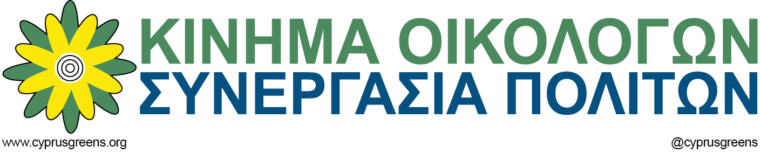

EX/NP/GP/588/2017

11th July 2017

To
Ms. Monica Frassoni & Mr. Reinhard Bütikofer
Co-Chairs
European Green Party

Ms. Ska Keller & Mr. Philippe Lamberts
Co-Presidents
Greens/EFA Group, European Parliament

Dear friends,

The results of the Conference on Cyprus in Crans-Montana, Switzerland

Although the Conference on Cyprus that took place in Geneva in January had foreseen a resumption of the Conference, this was not decided upon until the 9th of June due to lack of progress in reaching compromises on the 6 separate chapters under discussion. This resumption of the Conference had been agreed upon on the clear understanding that the three guarantor powers (Greece, Turkey & United Kingdom) would participate and reach a compromise concerning the overall Security issue and the Treaty of Guarantees, before discussions on the remaining 5 chapters would continue.

The reasoning for the resumption of the Conference centered on the conclusion that the lack of a clear framework concerning the security issue was obstructing progress in the direct negotiations between the two communities. So the two leaders agreed to the continuation of the Conference on Cyprus in Crans-Montana, Switzerland on June 28th and Mr Espen Barth Eide, Special Envoy of the Secretary General of the UN to Cyprus, undertook the task of creating a single document that would document the views of all parties concerned on the Security and Guarantees issue, based on the outcome of the meetings of the conference on Cyprus in Geneva and Mont Pelerin (2016-2017), in order to facilitate the Conference. (This document was only communicated to the respective parties on the 21st of June, offering very little time for amendments. Eventually, the document was withdrawn and not utilized due to misrepresentation of the positions of the parties). President Nicos Anastasiades and Turkish Cypriot leader Mustafa Akinci had also agreed to continue in parallel to the discussions on the Chapter of Security and Guarantees, the bi-communal negotiations in Geneva on all other outstanding issues, starting with territory, property and governance and power-sharing.

From a Greek-Cypriot side, - as during the previous round of the Conference (January 2017) -, the leaders of all Greek Cypriot political parties represented in Parliament escorted the President of the Republic of Cyprus (except the extreme-right ELAM party). I represented the Cyprus Greens, and I am therefore able to provide first-hand information concerning the procedure followed and lack of positive outcomes.

The Crans-Montana round of the Conference on Cyprus was planned for 10 days, from June 28th – July 7th.

We explain in detail in paragraphs 9 – 16 of the addendum, the reasoning for the abolition of the defunct Treaty of Guaranty and the withdrawal of the Turkish occupation troops. This position was met with cynicism and mockery by the Turkish Foreign Affairs minister Mr Mevlüt Çavuşoğlu. He publicly stated that the Greek – Cypriots and Greece should “awake from this dream”. It comes as no surprise that this intransigent stance halted progress at the Conference, and time was passing by with no tangible outcomes. In an effort to revive the Conference, the UN Secretary General Mr. Guterres provided, on June 30, a framework outlining the basic principles he considered of vital importance to be dealt with from the beginning in order to facilitate the drafting of a comprehensive agreement.

Even after the submission of the Guterres framework, very little progress was made. It seemed that there was a last flicker of hope that an agreement would be reached during the dinner in the presence of the Secretary General Mr Antonio Guterres on the 6th of July. On the previous day, 5th of July, President Anastasiades informed the political leaders that he planned to propose new compromises in the hope that it would save the Conference and incentivize Turkey to commit to a framework for the Security and Guarantees issue. This was a Hail Mary move, an effort to maintain the negotiations alive, a move with which we, as Green Party did not agree to, as we correctly foresaw than this specific move by President Anastasiades would not be reciprocated by Turkey, and the compromises made could be taken as a sign of weakness in the future . President Anastasiades, acting on its own initiative, submitted the package of compromise proposals the next day, 6th of July in the presence of the UN Secretary General in order to break the deadlock.

As foreseen, unfortunately, Turkey did not live up to expectations. When the UN Secretary-General expressed his intention of putting in writing the convergence points, Turkey’s Representative at the Conference, Turkish Foreign Affairs minister Mr Mevlüt Çavuşoğlu resolutely refused to allow a number of promises he had made to the Secretary-General to be set down in writing. I remind you that Turkey had abandoned the first Conference in Geneva in January, and now drove the Crans Montana conference to an impasse.

Turkey’s refusal to accept the abolition of the defunct “rights” of intervention stipulated in the Treaty of Guarantors and withdraw its occupation forces from Cyprus, even though Mr. Çavuşoğlu had indicated Turkey would accept them at the dinner, was the key reason the conference collapsed. Three days earlier, the Turkish Foreign Minister had bluntly revealed Turkey's position, according to which Ankara "needed these rights so that it can intervene throughout Cyprus whenever it deems it necessary". During the dinner it became evident that Mr. Çavuşoğlu was not willing to commit to any agreement in writing, forcing the Secretary General to call off the convention. After the conclusion of the Convention, Mr. Çavuşoğlu presented Turkey’s true objective, that of driving the negotiations under UN auspices to a dead end, in order to try to find a solution “outside UN parameters” as he stated .

We would like to underline, that from the very first day of his presence in Crans-Montana, the President of the Republic of Cyprus Mr. Anastasiades, submitted specific and comprehensive proposals. During the Conference, when the Secretary General asked specific positions to be presented on key hot issues, he did so, submitting specific, written proposals which addressed the concerns of the Turkish Cypriots. A specific written proposal on the chapter of Security and Guarantees was also submitted by the Greek Government, unlike the Turkish Government or the United Kingdom.

We will not give up the effort of reaching a just and comprehensive solution to the Cyprus Problem even though the outcome of the Conference and the failure to agree on further negotiations effectively throws a two-year process of the Cyprus peace talks into limbo. We hope that very soon the Secretary General of the UN will appoint a new Special Envoy and negotiations will recommence.

It is imperative that Turkey is made to understand that it needs to make specific compromises as well, and that no solution is possible outside UN parameters. We hope that you will stand by our side and support our efforts in trying to convince Turkey to do the right thing and give up the chokehold it has over the Turkish-Cypriot community, allowing the two communities to reach a peaceful settlement on the island, living together in Cyprus without the presence of foreign army or the interventions of the so called "mother countries".

We hope to arrange meetings with all of you to discuss in details further actions and the EU Commission’s stance towards the European Parliament resolution that asks for a freezing of the membership negotiations with Turkey and the withdrawal of the Turkish army from Cyprus.

We are hoping for these meetings to take place as soon as possible.

With Green Regards,

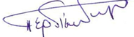

George Perdikes
President
Cyprus Greens-Citizen’s Cooperation

